**Prada Lab Tank System Manual**

Last updated by Taylor Lindsay Feb 2021

Table of Contents

Table of Contents 1

1. Tank Diagrams & List of Features 2

1a. Filtration System Diagram 3

1b. Reservoir System Diagram 4

1c. Tank Diagram 5

2. Calibration & Filter Replacement Schedule 6

2a. Daily Tank Checklist 6

3. Calibration Instructions 8

3a. pH sensor calibration 8

3b. Conductivity sensor calibration 8

4. Filter Replacement 9

4a. Carbon Filter Notes 9

4b. Mechanical Filter Notes 9

5. Water Maintenance 11

5a. Tank parameters 11

5b. Water Level Maintenance 12

5c. Salinity Maintenance 12

5d. Biofilter 13

6. System Controller 14

7. Future Installations 15

# 1. Tank Diagrams & List of Features

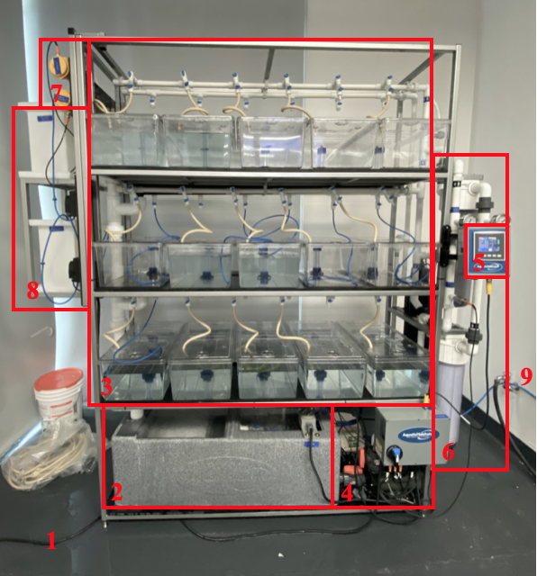

1. Filtration System

* Water cutoff valve
* Mechanical Filter
* Carbon Filter
* UV Filter
* Pressure Gauges
* Temperature Sensor
* Unused Filter Mount
* pH/Conductivity water source

1. Water Quality Sensors

* pH Sensor
* Conductivity Sensor

1. Dosing System

* Unused Dosing Reservoirs

1. Water Output
2. Power Source
3. Reservoir

* Filter pads
* Biofilter
* Heater
* Water level sensor

1. Tanks

* Water Inputs
* Air Inputs
* Air Stones
* Standpipes

1. Pumps

* Air Pump
* Water Pump
* Kill Switch

1. System Controller

## 1a. Filtration System Diagram

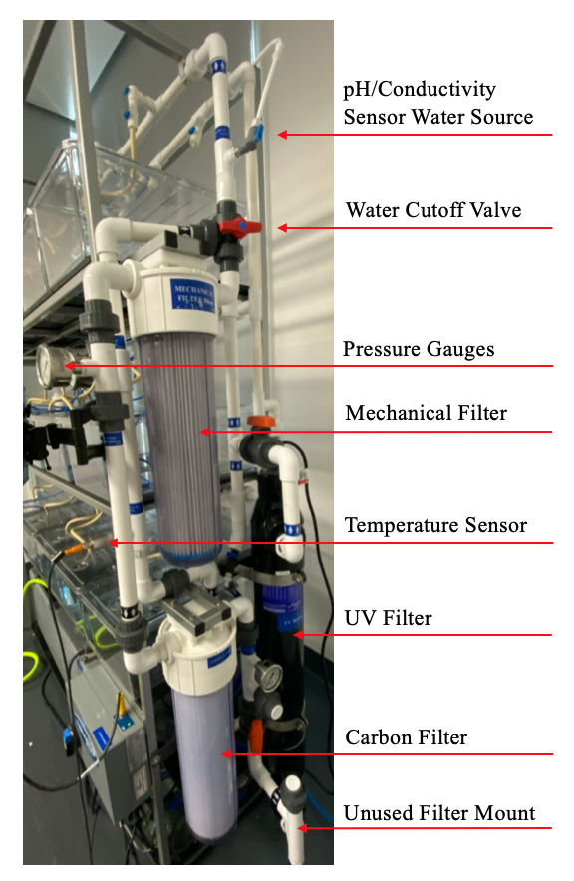

## 1b. Reservoir System Diagram

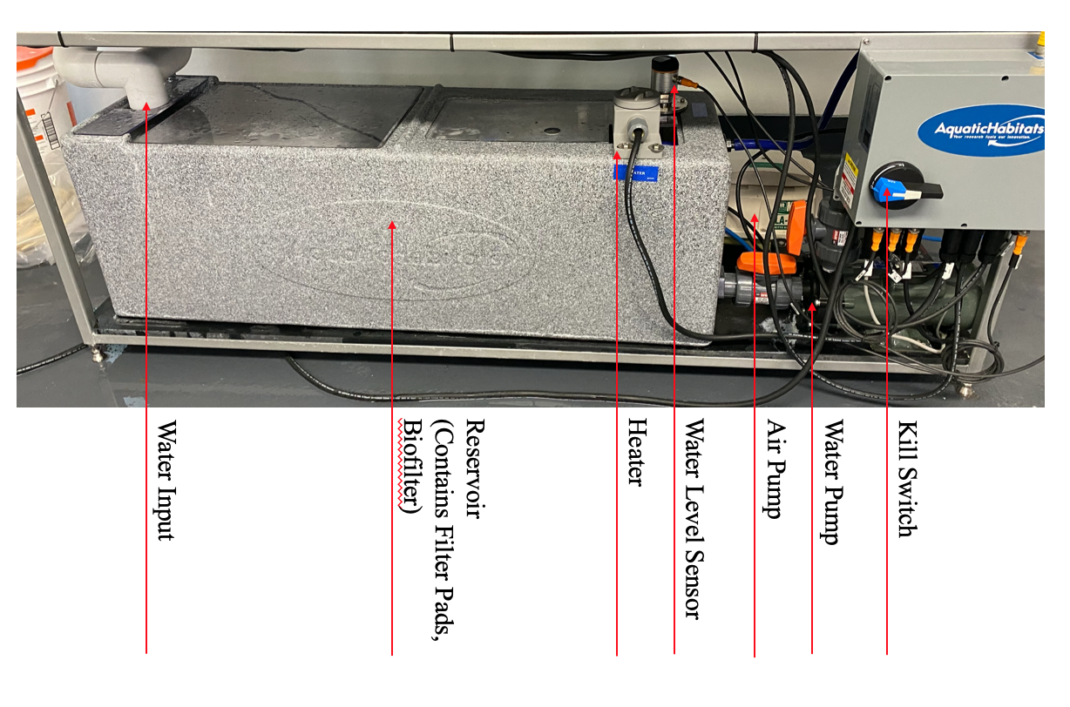

## 1c. Tank Diagram

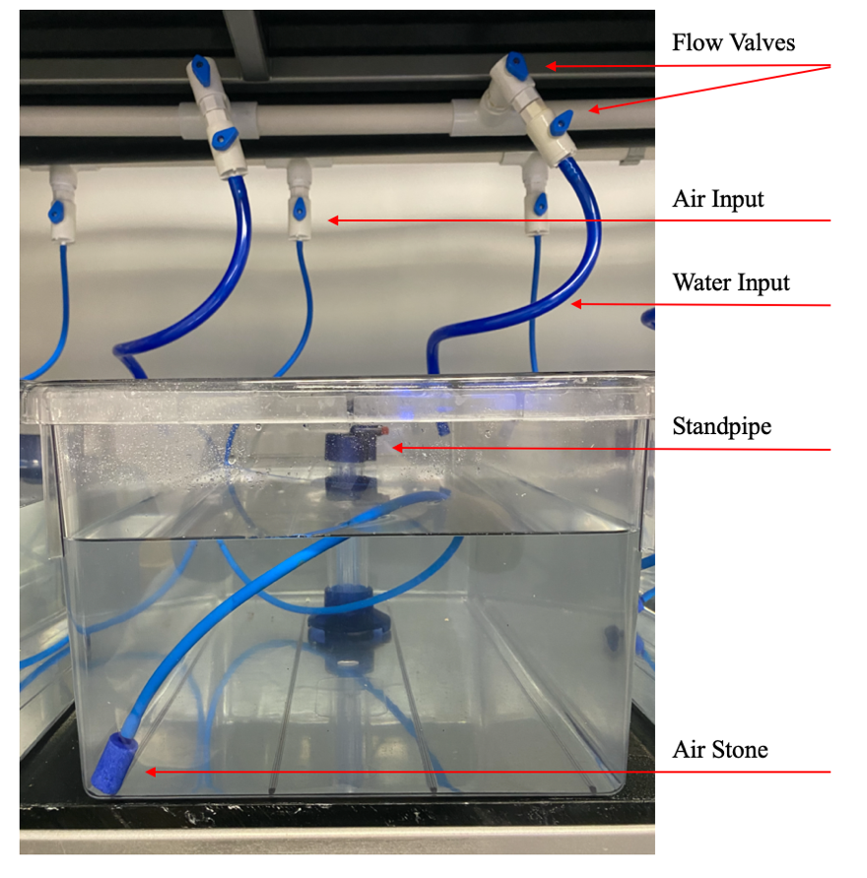

# 2. Calibration & Filter Replacement Schedule

**Carbon Filter**: Alternate cleaning & replacing every two months or if pressure difference exceeds 10psi*

**Mechanical Filter**: Alternate cleaning & replacing every month or if pressure difference exceeds 10psi*

**UV Filter**: Have checked once a year. Last check 01/20/21.

**pH probe:** Calibrate once a month. Have checked once a year.

**Conductivity probe:** Calibrate once a month. Have checked once a year.

**Filter pads:** Replace twice a week.

## 2a. Daily Tank Checklist

*Every weekday:*

* Record Water level
* Record Conductivity
* Record Temp
* Record pH
* Record O2

*Every Monday and Friday or as needed:*

* Check Ammonia/Nitrate/Nitrite
* Top off water (only if low)
* Dose system with brine (only if low)
* Change filter pad
* Enter data into digital log sheet

*See ‘Tank Parameters’

# 3. Calibration Instructions

When the sensors are removed, both will leak water, so it is best to put a towel underneath the probe units.

## 3a. pH sensor calibration

1. Prepare the pH 7 and 10 solutions in small containers
2. Close valves above and below the probe (no need to turn system off)
3. Remove probe unit*
4. Take the head off and flip the switch to ‘cal’
5. Submerge probe in pH 7 solution
6. Press and hold the button. A green light will come on, keep holding the button until it turns off
7. The pH reading on the computer should read 7 +/- 0.1
8. Repeat steps 5 through 7 with the pH 10 solution
9. Return the switch back to its regular position
10. Close the unit and screw it back into the tank system
11. Open the valves above and below the probe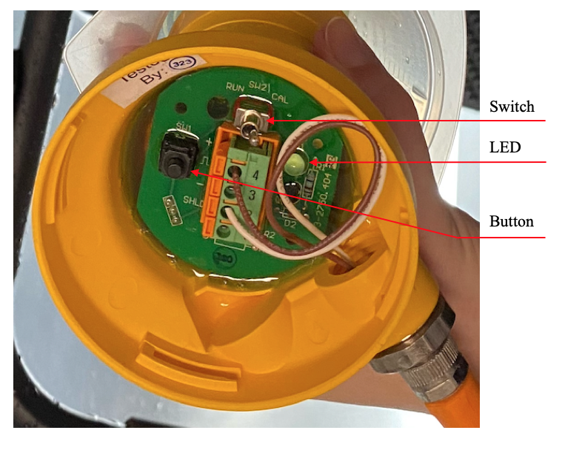

*There are two spinning components on the probe and they spin in opposite directions, make sure you are unspinning the one on the end, not the middle. Counterclockwise to loosen, clockwise to tighten.

## 3b. Conductivity sensor calibration

1. Prepare the conductivity liquid in a small container
2. Close valves above and below the probe (no need to turn system off)
3. Remove the power cord (orange and black electrical cord)
4. Remove the probe unit from the tank system and open the head
5. Re-attach the power cord
6. Submerge the electrode in the liquid, shake to dislodge any air bubbles
7. Press and hold the button until the red light goes off. If the light blinks multiple times rapidly the calibration was not successful
8. Remove the power cord
9. Re-tape the threating on the probe
10. Return probe to position, reattach power cord 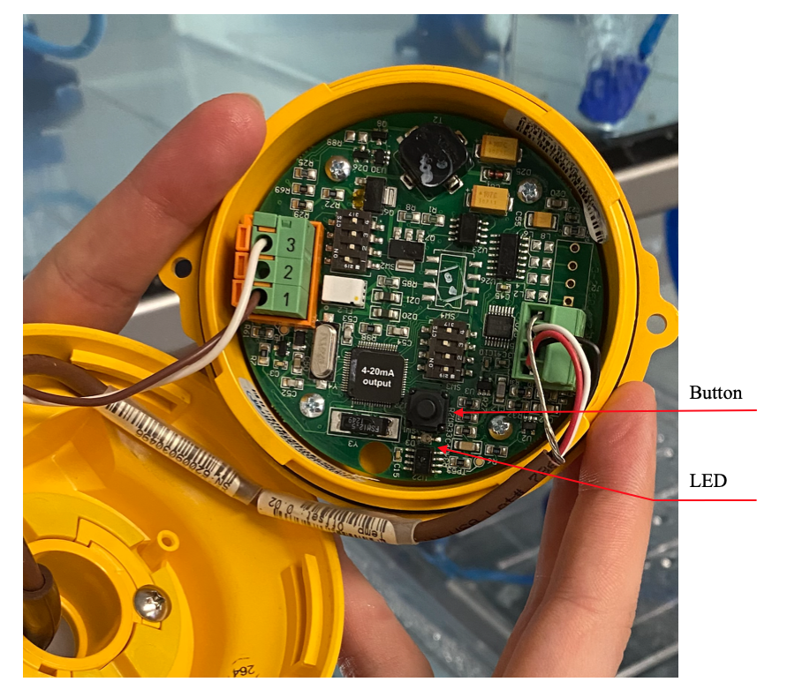

# 4. Filter Replacement

Replacing the carbon and mechanical filters follows nearly the same process:

1. Turn system off using the ‘feed fish’ setting or the kill switch*
2. Close valves above and below the filters to stop flow
3. Use wrench to remove the filter. Note that water will likely leak out, so you can put a bucket below to catch the water
4. Remove the filter from the tube and rinse it with clean water OR replace the filter with a new one
5. Check the screen at the top of the tube is secure**
6. Hand tighten the filter back into place
7. Press pressure release valves to let any air out
8. Open valves
9. Turn system on

## 4a. Carbon Filter Notes

* The carbon pellets should be kept in a bag
* The carbon can be cleaned by submerging it in clean water and agitating the bag until it is clean
* Changing or cleaning the carbon will result in a pH spike
* Carbon pellets can be disposed of in regular trash cans

## 4b. Mechanical Filter Notes

PHOTOS

*Turning off the system will cause the water level to rise in the reservoir. Make sure it will not overflow (ideally keep below 8” before you turn the system off)

**Screens at the top of the filters can be hot glued back into place if they have come loose

# 5. Water Maintenance

## 5a. Tank parameters

|  |  |  |  |  |  |  |
| --- | --- | --- | --- | --- | --- | --- |
|  | Units | Shutoff Low | Alarm Low | Ideal | Alarm High | Shutoff High |
| pH | -- | none | 7.00 | 8.00 | 9.00 | none |
| Conductivity | mS | none | 50 | 53 | 60 | none |
| Temperature | ˚C | none | 26.0 | 28.0 | 30.0 | none |
| Water Level | in | ? | 6.0 | 8.0 | 12.0 | ? |
| O2 | TBD | TBD | TBD | TBD | TBD | TBD |

**Pressure gauges:** the pressure gauges read the water pressure before and after water enters the filtration system. The two gauges should be equal (especially right after replacing a filter). If the difference between the gauges exceeds 10psi, then the filters need to be cleaned or replaced.

**Ammonia/Nitrate/Nitrite:**

## 5b. Water Level Maintenance

* A reservoir of **fresh**, clean water will be kept in the tank room
* This system has about 1” of evaporation per day
* Water level should be corrected 2-3 times a week
* Top off water level by attaching hose to pump, and setting it up as seen below.

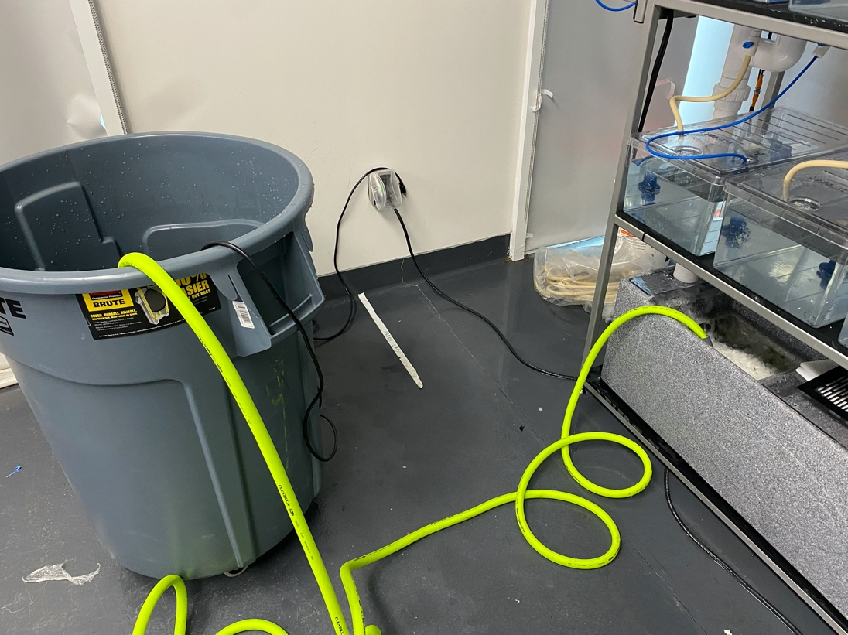

## 5c. Salinity Maintenance

* If salinity levels drop too low, they can be altered by manually ‘dosing’ the system with brine.
* We will use Instant Ocean Reef Crystals to make a brine to dose the system
* Dilute the salt in water so that it is fully dissolved before adding it to the system.

## 5d. Biofilter

<https://www.bulkreefsupply.com/rapidcycle-aquarium-cycle-kit-algaebarn.html>

The biofilter creates NO3 in the system

Starting a new biofilter:

* The spiked levels last 4-8 weeks from when you add the biofilter. Check ammonia, nitrate, nitrite for this period.

# 6. System Controller

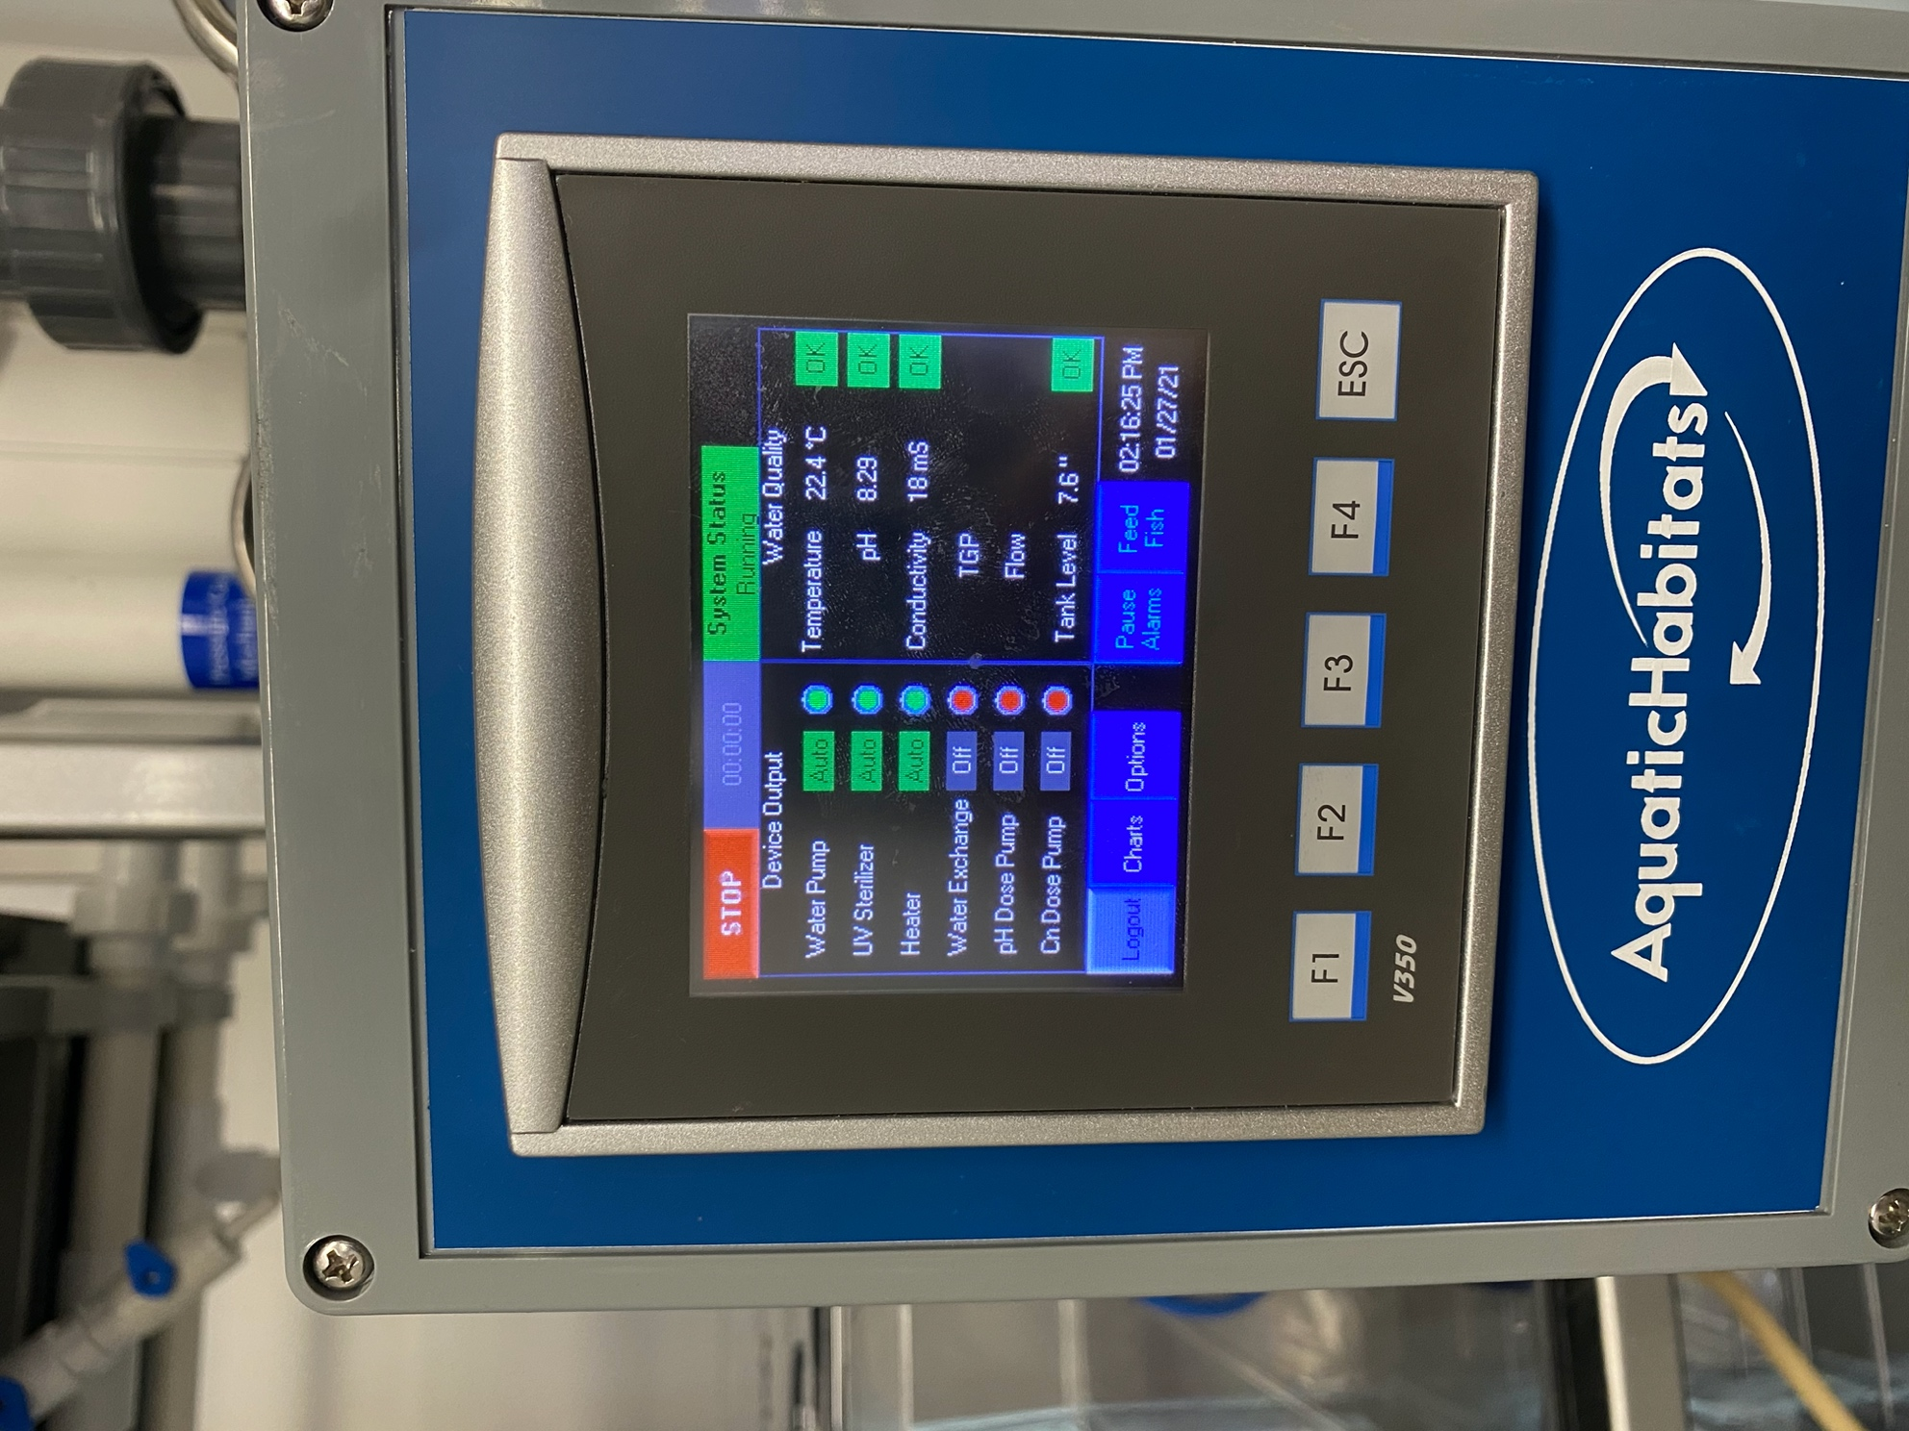Home Screen Controls

RUN/STOP: RUN will commence the startup sequence and start water flowing through the system. STOP will make it stop flowing.

Timer: Shows the amount of time the system has been on

System Status: Informs user of alarm status

Pause Alarms: Stops all alarms and all system cutoffs for *one hour*. Helpful when starting system up to allow time for the water to heat up.

Feed Fish: Temporarily stops water flow for a specified amount of time

Logout: Allows the user to log out. Current password is 1234

Device Output: Shows the status of the six main systems. Note that the heater turns on and off regularly. Only the first three systems are currently installed

Water Quality: Shows the water quality status reported by the probes in the system. Currently shows Temperature, pH, conductivity, and tank level. OK symbols indicate the status of each water quality parameter. These parameters are checked periodically and may take a few minutes to reflect changes in the system.

F1, F2, F3 ???

F4: moves ‘back’ one screen

ESC: Returns to home screen

Charts: Each probe regularly records data, and these recordings can quickly be viewed using the ‘charts’ menu

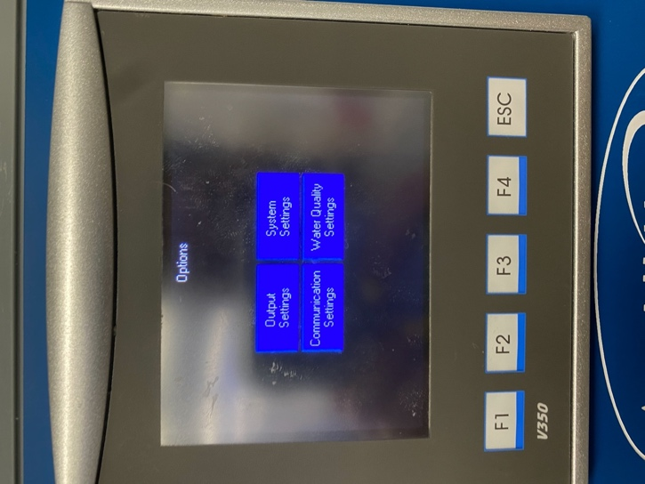Options: The options menu houses most of the controls for the system. Here, you can find the settings menus for the output, system, communications, and water quality.

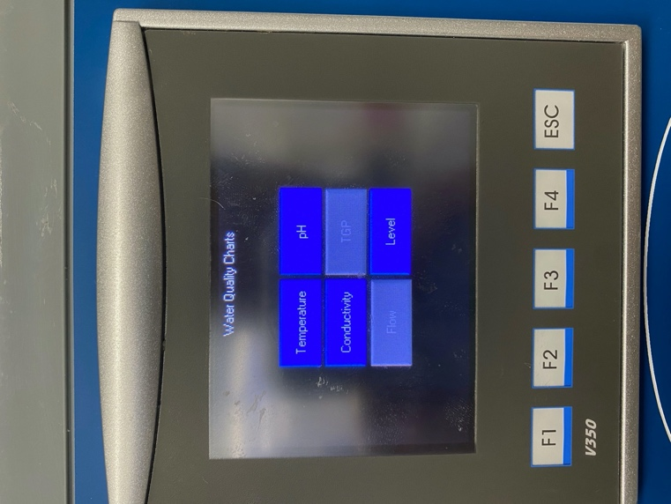 Output settings: Manual controls for the heater, UV sterilizer, and water pump. Each system can be turned to AUTO (the system automatically turns on or off according to the flow and needs of the system), HAND (the system will run continuously) or OFF (the system is off).

Communication settings:

System settings: Water exchange settings, advanced settings, password settings, and maintenances

Water quality settings: For each of the water quality settings measured by the system, you can manually change the desired parameters and cutoff values

## 6a. Alarms

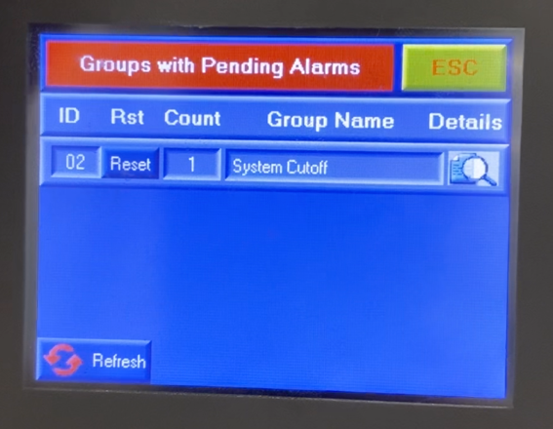When an alarm goes off, there will be an auditory signal and the system may stop flowing, depending on the type of alarm. On the home screen, there will be a red flashing button indicating the alarm. To check the source of the alarm or turn it off, push the alarm button.

The “Groups with Pending Alarms” lists the type of alarm that is going off, for example a system cutoff alarm will stop the system from flowing.

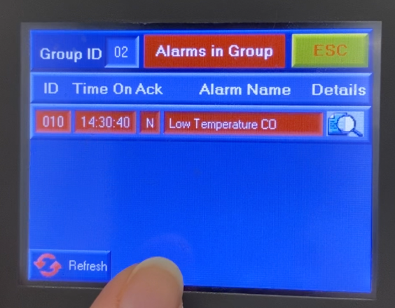To view the source of the alarm, click on the magnifying glass symbol. This will result in a list of the alarms within that group that are triggered and what the cause was (for example, here we see that the low temperature cutoff was triggered).

To turn an alarm off, go back to the first alarms page, and click the reset button. This reset will only last until the probe that measures that water quality variable does its next measurement before it goes off again.

# 7. Future Installations

1. Lights
2. Networking
3. Dosing Systems
4. Water Exchange from External Reservoir